Haybrook College
Annual Performance Report
2022-23

Contents
Introduction and School Context 3
Pupil Mobility 4
Analysis and Explanation 5
Demographics 7
Year 11 Outcomes 8
Year 11 Headline measures 8
Year 11 Number of GCSEs 8
Year 11 Comparative Groups 9
Analysis and Explanation 9
KS5 Outcomes 10
Analysis and Explanation 11
Year 10 Progress 12
Analysis and Explanation 13
KS3 Progress 14
KS3 English Progress Data 14
KS3 Maths Progress Data 14
Analysis and Explanation 14
Boxhall Profile 15
Analysis and Explanation 15
Attendance 16
Analysis and Explanation 16
Suspensions 18
Analysis and Explanation 18
Destinations 19
Analysis and Explanation 19

Introduction and School Context
Haybrook College is an alternative provision academy for pupils who have been permanently excluded for are at high risk of permanent exclusion from mainstream education. Haybrook College provides another chance for pupils to re-engage with education, make progress, and change the direction of their lives. All the young people who attend the College have significant and complex Social Emotional and Mental Health Difficulties (SEMHD). The College includes a KS3 and KS4 Alternative Provision and a Special School for pupils with social, emotional, and mental health needs (SEMH). The College also runs Wexham Park Hospital School (WPHS), which provides an education for young people of statutory school age who have serious medical conditions and are too ill to attend school.
The education pupils receive whilst at Haybrook College is tailored towards their individual needs and designed to give them the skills and knowledge they require to make positive life decisions to improve their futures. The curriculum is engaging and enriching, providing our pupils with a range of appropriate qualifications to move forward with the next step of their lives. The curriculum is further supported by cultural curriculum activities to enhance learning and personal development to that pupils can:
Become successful and confident learners, making progress and achieving qualifications at the appropriate level
Become confident individuals living safe, healthy, and enriching lives within their communities
Become independent citizens able to contribute to wider society.
To achieve this our curriculum and approach needs to be flexible and inclusive to motivate and provide challenge for all pupils, whatever their ability or special educational needs. Much of the work we do is within our hidden curriculum, ensuring pupils have access to a range of interventions that help to develop their personal and social development alongside their educational development. These interventions include therapeutic provisions such as counselling, speech and language therapy, occupational therapy, art or play therapy and animal therapy.
Haybrook College recognises that the outcomes for permanently excluded pupils are well documented and can lead to long-term disadvantages such as low employment levels, poor mental or physical health, and even involvement in crime and the prison system. Haybrook knows that high-quality education can be difference between long-term and success and failure, supporting pupils to move up the social mobility ladder when successful. Haybrook College has worked with educational psychologists to develop a trauma-informed approach supporting pupils to develop the ability to self-regulate their emotions and reconnect with adults to support their learning.

Pupil Mobility
Spring
Autumn
Analysis and Explanation
Pupils join and leave Haybrook College throughout the academic year. Pupils join via permanent exclusion, referral for intervention from schools or SBC, or EHCP consults from SBC or other local authorities. Pupils can access a range of provisions from short-term intervention courses to long-term provision for those that need it. Similarly, pupils can leave Haybrook College for reintegration to mainstream provision, more suitable special school provision has been identified, or they may leave the local area. Pupils remain on Haybrook College roll until such time that a suitable provision has been identified.
The data above indicates an influx of KS4 pupils in the first term, however many of these were for short-term intervention courses and they returned to their mainstream school. The real pressure has been in KS3 with a large number of pupils in year 9. There are more year 7 pupils joining than any time in the past. We are also placing more previously permanently excluded pupils back to mainstream than ever before.
The majority of pupils join us due to persistent disruptive behaviour but there has been an increase in pupils committing physical assaults on pupils or staff.
Although we provide long-term provision for those who require it, we always aim to support a positive return to mainstream school if appropriate. This can sometimes lead to a high number of transitions.
There were 296 (257 Pre-16 and 39 Post-16) pupils in total on Haybrooks roll over the academic year.
Of the Pre-16 Pupils:
- 133 started the year at Haybrook College
- 124 joined at some point during the year
- 21 returned to mainstream through Fair Access Process
- 4 pupils left the local area
- 2 pupils became Electively Home Educated
24 KS3 pupils attended HYPE intervention course.
- 19 or 80% manage to maintain the school place
- 1 or 4% transferred to a specialist provision
- 4 or 16% were subsequently excluded from mainstream school
16 KS4 pupils attended a short-term intervention course last 2-4 weeks before returning to their mainstream setting.
- 12 or 75% maintained their placement.

There were a total of 34 Post-16 pupils for academic year 2022-23:
22 were long-term pupils with the majority starting in the Autumn term
- 12 of these had ECHP’s
12 started in the Spring term to support SBC's need to provide education for asylum seekers that were new to the country.
- 7 were Unaccompanied Asylum-Seeking Children (UASC) – a provision set up to support mainstream schools
- 5 were ESOL students – a provision set up to support SBC ‘s need for asylum seekers

Pupil Demographics
 | Sep-22 | % | Jan-23 | % | May-23 | % | Aug-23 | %
Total Enrolment | 187 |  | 213 |  | 218 |  | 118
Male | 143 | 76.5% | 170 | 79.8% | 167 | 23.4% | 96 | 81.4%
Female | 44 | 23.5% | 43 | 20.2% | 51 | 76.6% | 22 | 18.6%
Year 7 | 11 | 6.0% | 16 | 8.0% | 22 | 10.0% | 24 | 20.0%
Year 8 | 23 | 12.0% | 22 | 10.0% | 32 | 15.0% | 25 | 21.0%
Year 9 | 26 | 14.0% | 29 | 14.0% | 28 | 13.0% | 26 | 22.0%
Year 10 | 43 | 23.0% | 43 | 20.0% | 41 | 19.0% | 43 | 36.0%
Year 11 | 65 | 35.0% | 72 | 34.0% | 71 | 33.0% | 0 | 0.0%
Year 12 | 17 | 9.0% | 24 | 11.0% | 21 | 10.0% | 0 | 0.0%
Year 13 | 2 | 1.0% | 7 | 3.0% | 3 | 1.0% | 0 | 0.0%
Disadvantaged | 109 | 58.3% | 129 | 60.6% | 131 | 60.1% | 75 | 63.6%
FSM | 89 | 47.6% | 99 | 46.5% | 112 | 51.4% | 69 | 58.5%
Pupil Premium | 100 | 53.5% | 111 | 52.1% | 119 | 54.6% | 76 | 64.4%

Year 11 Outcomes
Year 11 Headline measures
Year 11 Headline Measures | 2018-19 All % (59) | 2021-22 All % (61) | 2022-23 All % (67) | GCSE Level % (55)
5 or more GCSEs 4-9 including Maths and English | 0 | 5 | 1.5 | 1.8
5 or more GCSEs 1-9 including Maths and English | 34 | 36 | 60 | 73
5 or more GCSEs 4-9 | 0 | 5 | 1.5 | 1.8
5 or more GCSEs 1-9 | 34 | 36 | 60 | 73
4-9 in English and Maths GCSE | 0 | 5 | 3 | 3
1-9 in English and Maths GCSE | 43 | 45 | 64 | 78
4 GCSEs or equivalents | 47 | 49 | 65 | 80
3 GCSEs or equivalents | 57 | 57 | 74 | 90
2 GCSEs or equivalents |  | 66 | 83 | 95
1 GCSE or equivalent |  | 74 | 88 | 98
% English GCSE | 62 | 66 | 81
% English qualification | 90 | 82 | 93
% Maths GCSE | 65 | 61 | 78
% Maths qualifications | 88 | 69 | 89

Year 11 Number of GCSEs
 | % All Haybrook 2018-19 | % All Haybrook 2021-22 | Target 2022-23 | % All Haybrook 2022-23 | % Haybrook GCSE Capable
5 1 - 9 or equivalent | 34 | 36 | 40 | 60 | 73
4 1 - 9 or equivalent | 47 | 49 | 65 | 65 | 80
3 1 - 9 or equivalent | 57 | 57 | 70 | 74 | 90
2 1 - 9 or equivalent |  | 66 |  | 83 | 95
1 1 - 9 or equivalent |  | 74 |  | 88 | 98

Year 11 Comparative groups
Comparative data | 5 GCSEs 4-9 | 5 GCSEs 1-9
Male | 1.5% | 59%
Female | 0 | 61%
EAL | 1.5% | 57%
Non-EAL | 0 | 60%
ECHP | 0 | 56%
Non-EHCP | 1.5% | 60%
PP | 0 | 55%
Non-PP | 1.5% | 50%

Analysis and Explanation
Although national data is hard to come by the outcomes at Haybrook College show a positive trend in all areas when compared to previous national trends for APs and special schools.
This academic year saw more pupils sitting more exams than previous years. The total cohort rose 9.8% compared to last year and 13.5% compared to 2018-19. Those achieving 5 GCSEs or equivalents 1-9 was 60% compared to a national average of 25%, a significant positive difference of 35%. This is an increase of around 25% when compared to recent outcomes in 2018-19 and 2021-22.
Although we aim for 100% of pupils to leave with a maths and English qualification it is not always possible to achieve. 78% of pupils managed to achieve maths and English GCSE qualifications and 89% achieved this for any appropriate qualification.
88% of pupils achieved at least 1 GCSE with those that didn’t either being out of the local area or did not sit GCSE exams. The national average for APs is 61%,
Those achieving 5 GCSEs or equivalents 4-9 has reduced compared to last year, to 1.5% but remains above the national average of 1%.
Haybrook College has been able to offer a significant range of qualifications for both GCSE level and below GCSE level learners. In total, 19 different qualifications are delivered across the College from entry level through to GCSEs and BTECs. This highlights Haybrook Colleges commitment to ensuring that pupils have a personalised offer and high expectations of what our pupils can achieve.

KS5 Outcomes
KS5 Headline Measures | 2021-22 All % (33) | 2022-23 All % (22)
5 or more GCSEs 4-9 including Maths and English | 0 | 3
5 or more GCSEs 1-9 including Maths and English | 4 | 6
4-9 in English and Maths GCSE | 0 | 3
1-9 in English and Maths GCSE | 45 | 48
4 GCSEs or equivalents | 16 | 19
3 GCSEs or equivalents | 26 | 44
2 GCSEs or equivalents | 70 | 67
1 GCSE or equivalent | 86 | 85
% English GCSE | 66 | 74
% English qualification | 85 | 78
% Maths GCSE | 61 | 56
% Maths qualifications | 69 | 78

ESOL | 2022-23 All % (5)
% English GCSE | 0
% English EL qualification | 80
% Maths GCSE | 0
% Maths EL qualifications | 80

USAC | 2022-23 All % (7)
% English GCSE | 0
% English EL qualification | 57
% Maths GCSE | 0
% Maths EL qualifications | 71

Analysis and Explanation
National data is almost non-existent for Post-16 APs as there are very few across the country. Last academic year saw The Gateway working hard to support Slough schools and SBC with those seeking asylum within the local area. The hope was that this would lead to a longer-term revenue stream for the College. However, this was not sustainable.
Of the 22 pupils in our more regular cohort 3% managed to achieve 5 or more GCSE or equivalent at grades 4-9 which is a positive increase on last academic year. Those graded 1-9 also slightly increased. There was a slight increase in those achieving 4 or 3 GCSE or equivalents but a slight decrease in those achieving at least 2. 78% left with a maths and English qualification.
There was a significant breadth of study for this cohort with them having access to a range of vocational qualifications and digital skills.
ESOL
This group focussed on improving their basic English and maths ability in a very limited time span. However, 80% managed to achieve a basic literacy and numeracy qualification.
UASC
This group also focussed on basic literacy and numeracy but also had input from their home schools

Year 10 Progress
Year 10 Progress in English
 | None | Some | Enough | Excellent
Number of pupils | 7 | 21 | 11 | 0
Percentage | 18 | 54 | 28 | 0

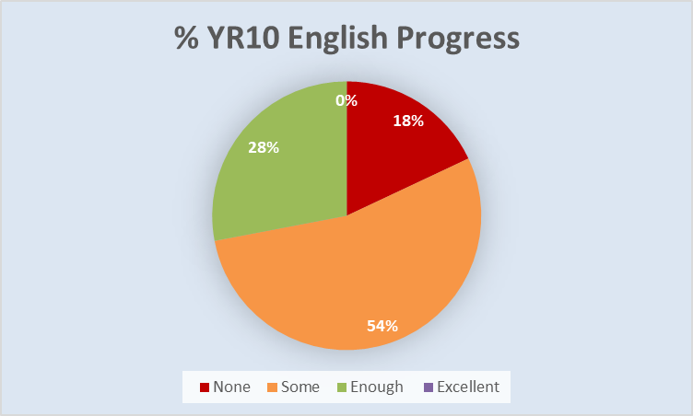

Year 10 Progress in Maths
 | None | Some | Enough | Excellent
Number of pupils | 5 | 19 | 15 | 0
Percentage | 13 | 49 | 38 | 0

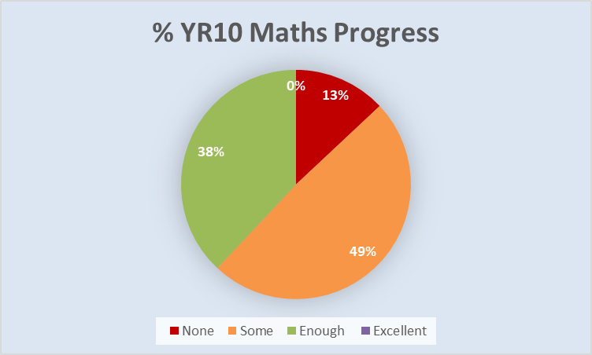

Analysis and Explanation
The expectation at Haybrook College is that pupils make progress from their starting points. Progress is determined by the individual teacher for each subject, in line with targets set each term and expected curriculum outcomes. Teachers report on progress for those making none, some, enough, and excellent progress.
The progress data includes those that were on roll at the time of this report. It does not include the data of those pupils who have returned to mainstream or another provision. This has dampening effect on the progress data as we actively seek to push those progress really well back to mainstream provision.
There were 39 year 10 pupils on roll across the College at the time of this report. 82% are making some or better progress in English and 87% in maths. 5 pupils did not make any progress in English and maths. Of these 5:
  - 3 pupils were moved out of the area for their own safety
  - 1 has very poor attendance linked to criminality
  - 1 has very poor attendance linked to anxiety
2 further pupils did not make progress in English, which is linked to the learning needs and engagement

KS3 Progress
Progress in English
 | None | Some | Enough | Excellent
Number of pupils | 5 | 28 | 36 | 9
Percentage | 6 | 36 | 46 | 12

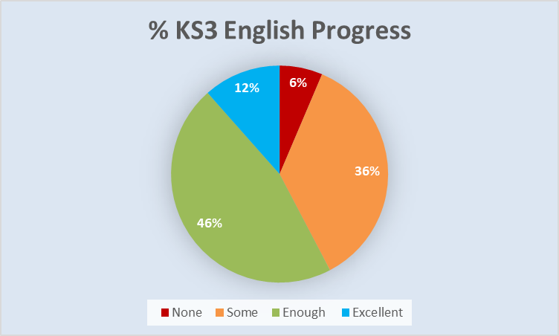

Progress in maths
 | None | Some | Enough | Excellent
Number of pupils | 4 | 34 | 30 | 10
Percentage | 5 | 44 | 38 | 13

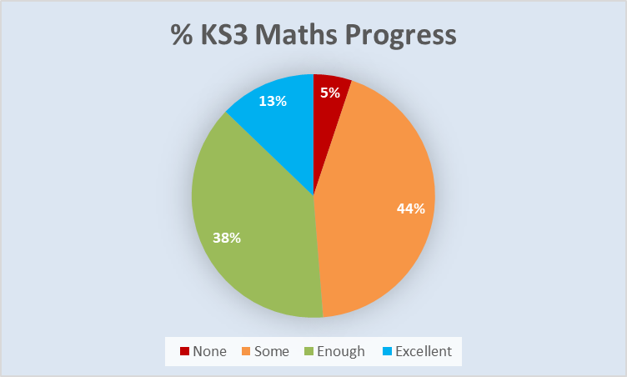

Analysis and Explanation
For the most part, progress at KS3 has been positive. Progress is determined by the individual teacher for each subject, in line with targets set each term and expected curriculum outcomes. Teachers report on progress for those making none, some, enough, and excellent progress. The progress data includes those that were on roll at the time of this report. It does not include the data of those pupils who have returned to mainstream or another provision. This has dampening effect on the progress data as we actively seek to push those progress really well back to mainstream provision.
In total there were 78 pupils in KS3 and a similar percentage made some or better progress, 94% in English compared to 95% in maths. A higher % were judged to make excellent progress in KS3 than in KS4. The data shows that the vast majority of pupils are making progress.
4 pupils were considered to be making no progress in maths and English at KS3. Of those 4 pupils:
  - 2 were moved out of the area but remain on roll as no provision has been identified
  - 1 joined very late in the term
  - 1 has struggled to engage with his curriculum
1 further pupil has not made progress in English at KS3 and is educated offsite but will be transitioning back to Haybrook College this academic year

Boxall Profile
For academic year 2022-23 we have utilised the Boxall Profile to measure the non-academic impact of Haybrook College on our pupils. The Boxall Profile measures a developmental strand, measures aspects of the pupils’ cognitive, social and emotional development that influence
how well they are able to learn and function in the classroom, and the diagnostic strand, measures aspects of the pupils’ challenging behaviours that prevent successful social and academic performance.

 | Developmental |  | Diagnostic
 | Pupils making Progress | % | Pupils making Progress | %
Millside | 35 | 58 | 30 | 50
Springboard | 12 | 48 | 8 | 32
Activate | 13 | 65 | 8 | 40
Apollo | 2 | 25 | 3 | 38
Interim | 12 | 40 | 11 | 37
Overall | 74 | 52 | 60 | 42

Analysis and Explanation
The Boxall Profile data indicates that we are having more impact with supporting pupils in developing their social and emotional aspects of learning but less impact on their behaviours that have a positive impact on academic performance. This is an interesting outcome given the overall outcomes of this cohort of pupils. We feel that there may be some issues with the data as this is the first time it has been used across the year. Some staff may have been overly generous on the initial assessment making progress harder to measure. Those that have made positive progress are also returned to mainstream so second assessments may not take place. The strategy group will be looking at this in more detail to determine what else could be learnt.

Attendance
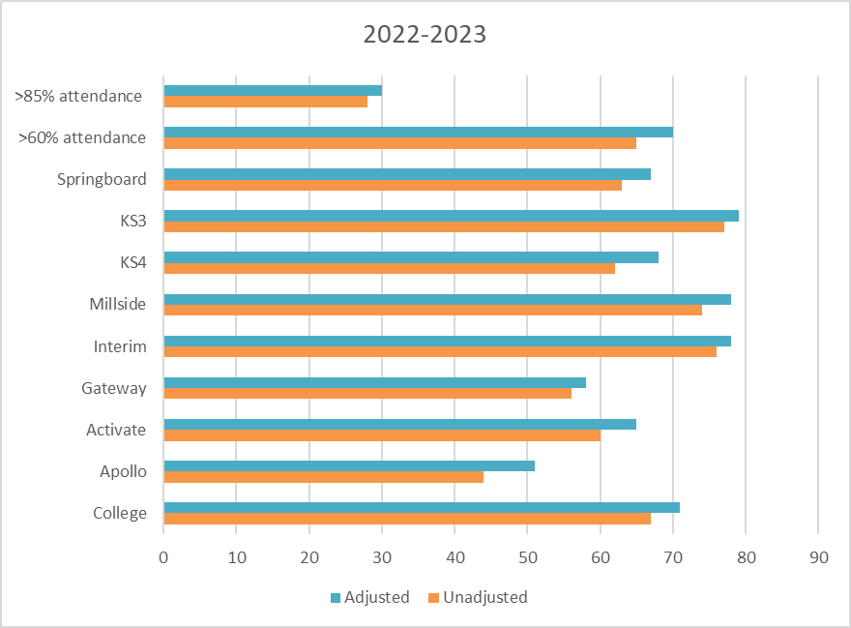

Analysis and Explanation
Pupils at Haybrook College are expected to attend full time and measures are made against 25 hours of education and not attendance to timetable as some providers do. We measure attendance is two ways: unadjusted and adjusted.
Unadjusted attendance is our raw data for every pupil on roll. That includes pupils that may have:
- Periods of non-attendance due to transition to Ap
- Refused to attend following exclusion from mainstream
- Mental health issues leading to emotionally based school refusal
- Moved out of area but has not been taken off roll due to not having another provision.
Adjusted attendance attempts to give a more realistic picture by withdrawing those with good reason for being off school, i.e. those medically unfit or out of the area and/or awaiting provision. We continue to work alongside all services in all cases.
Overall national absence rates for APs has increased over the last few years from a high of 31% in 2020-21 to 39.8% in 2022-23. This means a national attendance rate of 60.2% in 2022-23 (Pupil absence in schools in England, Autumn term 2022/23 – Explore education statistics – GOV.UK (explore-education-statistics.service.gov.uk)
Compared to last year, unadjusted attendance increased by 3% to 67%, which is 6.8% above the national average for AP’s. Adjusted remained within 1% at 71% for all pupils.
The percentage of pupils with over 60% attendance increased by 3% but the percentage of pupils with over 85% attendance fell by 12%.
There was an increase in KS4 and KS3 attendance however KS3 attendance rates are higher than KS4. The year group with the lowest attendance rate is year 11 and this academic year there was a higher-than-normal proportion of year 11’s at Haybrook College.

Suspensions

Analysis and Explanation
For 2022-23, there have been a total of have been a total of 88 suspensions losing 83 days of learning. The average length of exclusion was 1.7 days. 4 pupils were responsible for 26% of all exclusions.
Compared to last academic year there has been a 27% decrease in the overall number of exclusions, a 51% decrease in the number of days lost and the average length of exclusion has reduced by 0.5 days.
The main reason for suspension remains physical assaults against an adult, which as a percentage of total exclusions has increased by 13% compared to last academic year, but as a total number remains largely the same. This is followed by physical assaults against a pupil (including fighting), and then persistent disruptive behaviour.
There have been no permanent exclusions at Haybrook College for 15 years.

Destinations
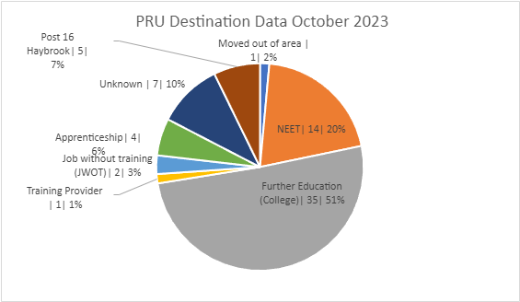

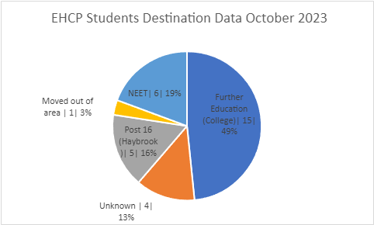

Analysis and Explanation
The Haybrook College Careers leader supports our pupils with moving on to their destinations and works with local colleges to ensure that our pupils are able to find appropriate and sustainable placements. We are committed to supporting them through to February after they leave and employ staff to visit pupils 2 days per week.
In total 72.5 % of Pre -16 pupils and 52% of Post-16 pupils were EET. The team continues to work closely with all services to support those pupils that are NEET.

